UNIVERSITY OF THE EAST

Rating
152 Samson Road, Caloocan City
College of Engineering
Information Technology Department

CCS2102 – OBJECT ORIENTED PROGRAMMING
Laboratory Activity 8

Name |  | Section:
Student Number |  | Professor: | Celis, J. R. E.

INSTRUCTIONS:
- For each problem, paste the code and sample output here.
- Make sure your name and student number are printed at the end of the output.

EXAMPLE:

Sample Problem:

Create a program that accepts two numbers, then displays the sum, difference, product, and quotient.

Code: Sample Output:
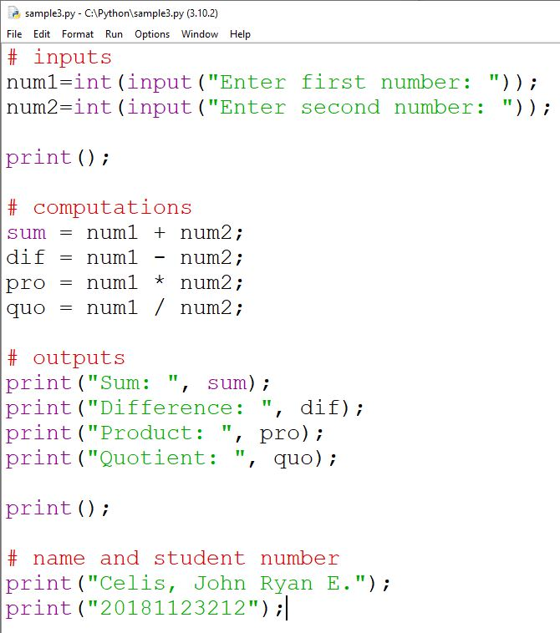
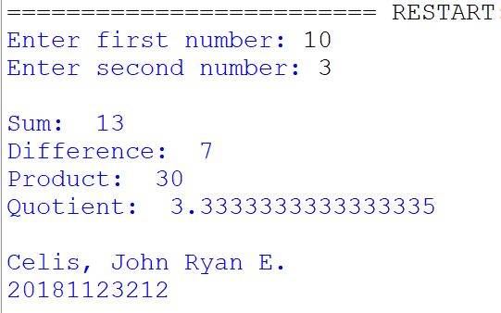

Problem:

- Modify the Function Overriding example in the lecture.
- Add another bank called PNB.
- The rate of this bank depends upon the Principal amount.
  - If the Principal amount is less than or equal to 50000, the rate is 7.5%
  - If the Principal amount is more than 50000, the rate is 5%.
- Display the Rate and the Interest.
- Add this activity in your Journal.

